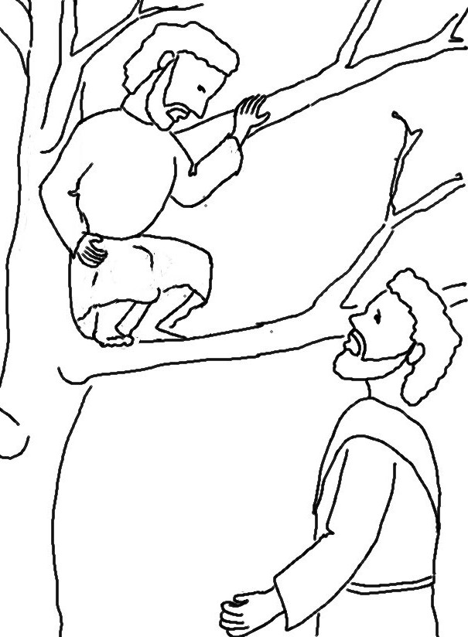

For the Son of Man came to seek and to _ _ _ _ the _ _ _ _.
Matthew 19:10_{NLT}

